**ASSIGNMENT 1:**

**TRAFFIC FLOW MANAGEMENT SYSTEM (TFMS)**

**LOGICAL MODEL:**

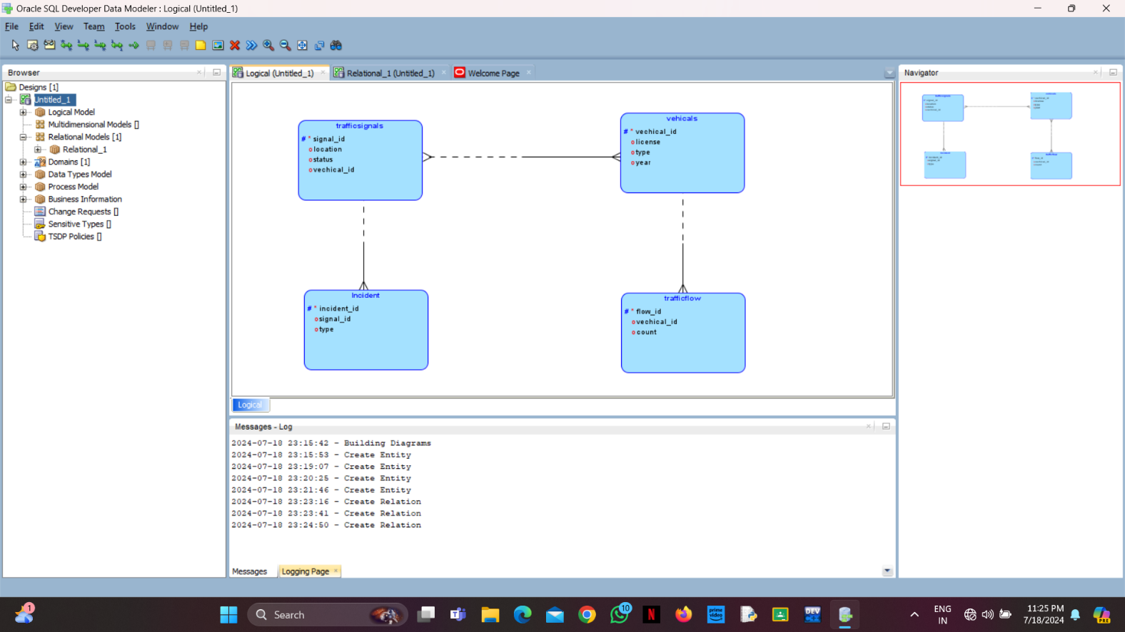

**RELATIONAL MODEL:**

